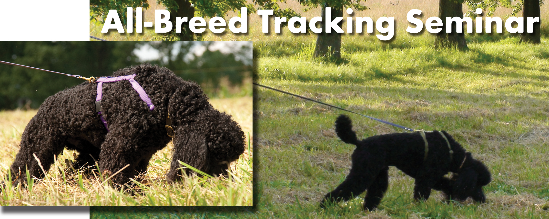
Tracking is a fascinating sport that uses your dog’s brains, requires no expensive equipment, and teaches you how to learn from (and admire!) your dog as you work as a team. This outdoor seminar is for both experienced trackers who want to improve their dogs’ skills and for newcomers interested in scent, nose work, and how to start tracking. Carol Pernicka has been teaching tracking for over 20 years and has done seminars across the U.S. for kennel clubs and Search and Rescue groups. She is one of a small number of people who have put multiple CT (Champion Tracker) titles on dogs. She has worked with over 100 breeds and mixed breeds in her 30 year career teaching tracking and obedience. Her students have earned multiple TDs and TDXs, as well as CTs and VST titles with various breeds, including Standard Poodles, Clumber Spaniels, Norwegian Elkhounds, Border Terriers, and Shelties.

The seminar will cover TD, TDX, and VST levels.

Carol will select demonstration dogs in advance based on questionnaire responses, and customize the seminar according to the participants’ experience and interest, covering as many training levels, problems, and questions as possible. While not all particpants may track with their dogs, all will increase knowledge and learn skills.
.

NAME
ADDRESS
PHONE EMAIL
Tracking Seminar with Carol Pernicka June 11 & 12, 2011 hosted by Go Dogs! Omaha, Ne. Mahoney State Park, located between Omaha & Lincoln, Nebraska
Registration for the two day seminar is $140.00. Please register early as demand will be high. Final deadline for registering is May 31.
We will send a confirmation e-mail and questionnaire about your experience and areas of interest when we receive your registration form and check.
The confirmation e-mail will also provide location, directions, times, and other details.
Fill out the form to the right and send it with your check made out to:
Go Dogs! Inc..
Mail registration and check to:
Mary Ruhe
2211 So. 161st Circle Omaha, Ne. 68130
agildog@tconl.com
402-334-7941

(Photos above: Dawin Dolce Con Brio, a Standard Poodle working in a Carol Pernicka seminar)

