K9 Funatics is proud to present a Jerry Rowe Sheep Clinic!!
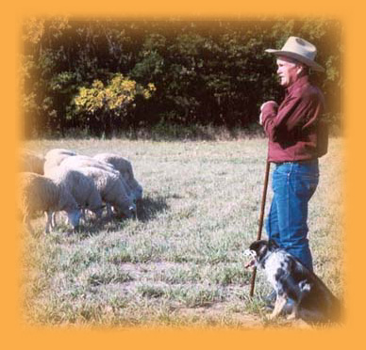
March 17-18, 2012
At K9 Funatics/Roanoak Aussies
345 County Road 12, Ceresco, NE 68017

Jerry and Sharon Rowe began their dog herding career in the early 60’s. After purchasing their first registered Australian Shepherd, they discovered the intelligence of these dogs and became interested in preserving the herding instinct and promoting the versatility of the Australian Shepherd as a breed. In 1970 they traveled to Kentucky for the International Border Collie Competition where they met Lewis Pence, who helped launch what had become a dream to promote stock dog herding with loose-eyed breeds. Together with the Colorado Collie Club, they formed the first all-breed herding club: Stock Dog Fanciers of Colorado. They then organized the first ever herding competition for loose-eyed dogs at their farm in Broomfield, CO. Since then they have been instrumental in promoting loose-eyed stock dog training by holding weekly classes and individual lessons. In addition, they have held competitive events at their farms for more than 40 years and have competed in trials and competitions, including ASCA,AKC, CKC, AHBA and USBCHA.
Jerry is a senior stock dog judge and has been involved with the ASCA Stockdog program since the beginning. Jerry travels throughout the year judging for ASCA, AKC, CKC, AHBA and USBCHA! While living in Colorado, Jerry had students with many herding breeds. His methods of training involve working with the animals to get the most out of them by enhancing their natural instinct without using force. He does not believe in pushing the dog faster than it can comprehend.
Working spots are limited to 7 so that everyone gets plenty of time and instruction at Jerry’s clinics! Auditor spots are unlimited.
Dates: March 17-18, 2012
In case of inclement weather, the clinic will be cancelled.
Time: 9:00 am to 4:30 pm (1 hour lunch break)
Cost: Participants (Limit 7)
$250 for the weekend
Auditors
$50/day
Make checks payable to K9 Funatics
Mail to: Monica Barger, 345 County Road 12, Ceresco, NE 68017 (402)570-0012

K9 Funatics and Jerry Row Sheep Clinic

Name:_____________________________________________________________
Address:___________________________________________________________Phone:_____________________ Email:__________________________________
Dogs Name:
1.___________________________ Breed:_______________________ Age:_____
Experience Level on Stock: ______________________________________________________________________________________________________________________________________
What are your goals for your dog at the clinic?
_________________________________________________________________________________________________________________________________________________________________________________________________________
2.__________________________Breed:________________________Age:______Experience Level on Stock:
______________________________________________________________________________________________________________________________________
What are your goals for your dog at the clinic?
_________________________________________________________________________________________________________________________________________________________________________________________________________
Are you signing up for a Working spot____ or an Auditor spot______
Working spots are $250 for the weekend, Auditors are $50/day.
Amount enclosed:___________________
Mail Checks and registration to: Monica Barger
345 County Road 12
Ceresco, NE 68017

