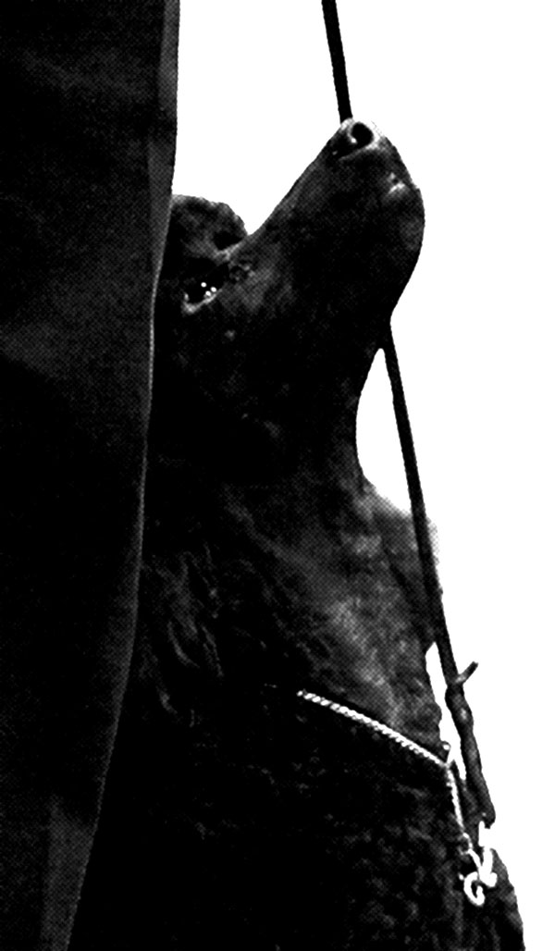
Focus On Heeling Syllabus Week 1
Most people do not reward often enough, especially in the beginning stages of a behavior and don’t get excited enough when the dog does something well. We will be rewarding constantly, every few steps for quite a while in order to build a strong behavior. Don’t be stingy. Reward EVERY correct response!
“Cookie Viewing is NOT Motivational!”
- Patti Russo
Motivating Forward Movement
We want to teach the dog that a light correction to move forward is rewarding not scary. First, lightly restrain your dog by his collar, toss a cookie on the floor about 3 feet away. Rev your dog up by saying, “READY, STEADY, GO!” and let him lunge to get the treat. Next, repeat the above but also give your dog a light pop/tug towards the treat as you say “GO!” Next, hold the treat in your hand out from the dog’s nose and pop towards the treat. Be sure to always praise too!
Define Heel Position – From the AKC Rules: “The area from the dog’s head to shoulder is to be in line with the handler’s left hip.” Also, the dog should maintain that alignment and not shift forward and back, in or out. Body should be straight in line with direction you are going. You must visualize what the correct position should be in order to train it!

Touch Heeling
Leash in RIGHT hand. Food in LEFT hand held between thumb and middle of fingers. Palm down. With dog in heel position, hold food in LEFT hand in such a position that dog will be in correct heel position when TOUCHING your palm. ANCHOR YOUR ARM and HAND in that position! Let dog lick and nibble cookie in palm, when he pushes into your palm reward by allowing him to get the treat.
Reload treat in palm. Remember to ANCHOR your hand/arm position. Let dog start licking treat, move forward one or two steps. Only release treat when dog is pushing into your fingers. Repeat over and over, just 2 or 3 steps. Remember to ONLY release treat when dog is pushing into your fingers. If you have been successful several times at 2-3 steps now go 4-5 steps. If dog gets distracted and pulls away from your palm, you should stop and get his attention again. Remember the 80/20 rule!
It is NOT important that the dog be sitting at the beginning of heeling at this point in training. Repeat the Touch Heeling every day for 2-3 minutes!

Doggie Zen
We need to teach our dog that looking at the treat in many cases does not earn them the treat; looking at our FACE does though. Have dog sitting in front of you, in order not to confuse this with heeling. Show the dog you have a treat in your hand. Now move that hand out to the side at shoulder height. Your dog will probably stare at it and even try different behaviors to get it. Do nothing. Eventually your dog will look at your face (their source of information) wondering why he is not getting the treat. Say “YES!” enthusiastically and reward from the OTHER HAND. Repeat using one or the other hand each time. Do this until your dog will NOT do more than a quick glance at the hand out to the side before looking intently at your face. Tell him how smart he is!!

Get On The Pot!
We are going to use a technique called SHAPING FOR DEMAND. Get out your platform which should be 1-3” tall and just large enough for your dog to put both his front feet on it. An upside down food dish usually works well.
Have a number of treats in your hand and show them to the dog. Lure him to the platform and as he starts to lick the treats in your hand (don’t let him have them just yet!) help him put ONE front foot and on the platform and let him have one nibble. As SOON as both feet are on the platform (sometimes you can settle for just one foot at first) start giving him one treat after the other. Next, and this is very important, BEFORE you run out of treats, pull him off the platform with his collar or gently push him back on his chest. Step away from the platform a couple feet.
Wait a few seconds then repeat the above steps. Be happy as you approach the platform. Always make sure you have treats left over in your hand when you pull him away. Remember, the behavior does not end because the treats run out, rather, the treats stop when the behavior ends. Think about that! By pulling him away from the treats and ending the behavior that had earned him the reward, you are creating a DEMAND in him to WANT to do the behavior.

Up Sits or Scoot Sits
It is very important that your dog have a TUCK sit and not a ROCK sit. A ROCK sit will cause the dog to fall back out of heel position. To encourage a TUCK sit we will do Up Sits.
With the food in your RIGHT hand at the dog’s nose, lure forward then up a little to assist the sit. At the same time, put your left hand lightly on the dog’s rump, just above the tail. Use light pressure forward to encourage the dog to scoot their rear end forward towards the front feet. Be sure to work on a nice straight sit in perfect heel position.
Homework
- Practice heeling a straight line with Touch Heeling. Practice for about 1-2 minutes several times a day RELEASING FREQUENTLY. If the dog should lose focus and pull away, regroup and start over.
- Practice 4-6 Up Sits twice a day.
- Practice your Doggie Zen twice a day, with a variety of treats. Once your dog starts getting good at this, start lowering your hand with the treat in it, towards your side. This will help your dog learn to not focus on your hands when doing a recall.
- Practice having your dog get on the pot. As soon as your dog demonstrates the ability to get on the pot himself, get the lure outta there! First hold the food a little higher, then behind your back. Be sure to walk your dog away from the pot after each repetition. This will help make him want to get back on to earn treats.
- PLAY with your dog! Do something to interact such as playing tug or with your hands.

Remember the 80/20 Rule …You should strive for 80% success. That means if you have more than 2 failures out of 10 tries, you have over-faced your dog and need to adjust your exercise. If my dog fails twice in a row I will take it slower or adjust the exercise to get better success, ie less steps, a quieter place, better treats etc.

Focus On Heeling Syllabus Week 2
It is so important to break exercises down into parts or behaviors. Master each behavior separately and do not put them together until all are performed well, only then can you put them together.

Review
- Heeling with head up and nose touching food, in a straight line or large circle left.
- Doggie Zen – lowering hand to side
- Up Sits
- Get on the Pot – See next
Left Turns – Executing a good left turn is very important for good heeling. Many teams fail to do this properly and end up with a crash at every left turn and a poor inside portion of the figure 8.

Get on the Pot – Adding Turns

Have dog get on the pot a couple times with his front feet, reward, then release off the pot. At this point you should not need to LURE to get on the pot, just wait and allow dog to want to get on. You may move around the pot a bit to encourage him to move toward it. Most will get right on if you have been practicing and making it VALUABLE for them to do it.

Have dog get on the pot. Stand in FRONT of dog, and hold food in front of his nose. Take a step to your right around the pot. As soon as dog moves his rear ONE STEP to HIS right, praise and reward! After the dog is reliably doing this move, you can name it “IN.” Repeat by stepping the other direction, reward for dog moving left.
Next, stand beside dog on the pot. With food at the dog’s nose, move the food towards the dog’s left shoulder. As soon as the dog moves rear legs “IN” towards you, praise and reward.

¼ - ½ Turns Left
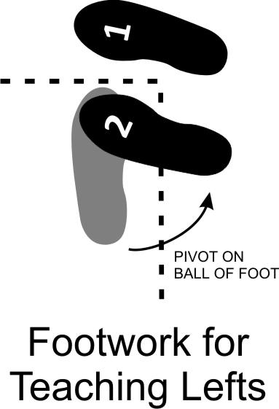
FOOTWORK for the teaching process: Right foot makes a ‘T’ in front of left foot. Left foot will then pivot on the ball of the foot.
With dog in heel position, put leash behind you close to the level of the dog. Food is in left hand at dog’s nose. Keeping the leash snug, make the T with your right foot (1), then, as you pivot on the ball of your left foot (2), you will turn he dog’s nose towards his left hip. As soon as the dog takes one step sideways towards you with his REAR legs praise and reward. As the dog masters this, you can add the word “IN” and you will reward when the dog’s body moves in enough to align with your direction.
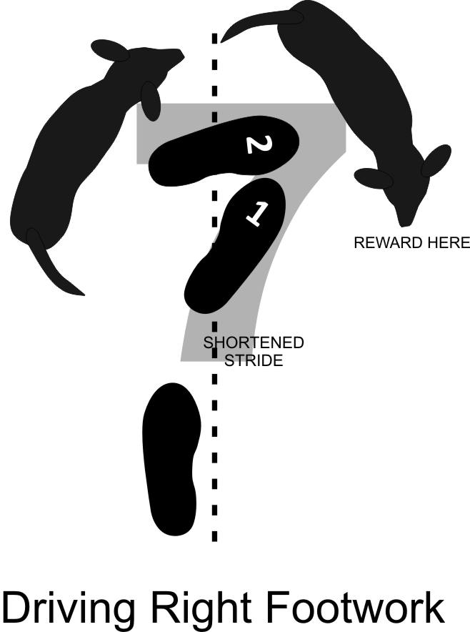
Driving Right
FOOTWORK: While walking in a straight line, step forward with your right foot and turn it 45º to the right (1). Bring your left foot into the right toe, (looks like the No. 7) so that the right toe is pointing towards the ball of the left foot (2).
As you take the step with your right foot, bring the food, which is in your RIGHT hand, to the dog’s nose. When you step with your left foot to complete the No. 7, bring the food tightly around you and reward next to your right leg. Do not complete the turn with your feet. Only your shoulders will turn as your feet create the No. 7.
You are actually practicing a “half about turn” which will be built into the full about turn next week. Take a moment each time you start the “half about turn” to get your dog excited with “Ready…!” and use a word for the move such as Hurry or Tight.
Homework
- Practice Doggie Zen and start using food in BOTH HANDS. Wait until the dog looks at your face and immediately say YES! Reward from one hand OR spit reward from your mouth. Gradually lower hands towards your legs. One day this will be your front position and your dog is so well focused on you that he will only look up at your face.
- Practice turns on the pot, both in front position and at your side, moving clockwise and counterclockwise.
- Get a large square cardboard box or something similar. Walk slowly in a square around the box with your dog between you and the box and doing a ¼ turn left at each and every corner. Reward for each GOOD effort of your dog. Do just 2 squares per session.
- Practice your footwork of the No. 7 and driving right for the reward.
- Always practice your Touch Heeling in a straight line, several times a day. Be sure to reward every 3-8 feet. Do not be stingy with the food. Try to see how often your dog can be perfect with no lapses in focus on the food. If you are successful, then you can heel a little further.

Remember… the DOG tells you when to advance!

Focus On Heeling Syllabus Week 3
Review
- Doggie Zen - Hands at sides holding food. Reward when dog looks at your face.
- Faster turns on the pot.

Touch Heeling—Removing Food
Now that your dog can heel well with the food right at his nose and has good focus, we will start to remove the food from the nose but still keep it in sight.
Start by doing the usual Touch Heeling with the food at the nose. After a few steps, pull the food away from the dog’s nose for ONE STEP. Quickly praise and reward! Repeat, but this time heel TWO STEPS. Quickly praise and reward! Keep repeating this pattern, taking a varying number of steps but not always increasing number of steps, ie 4 steps, 6 steps, 3 steps, 8 steps. Ping pong the number so that the dog does not know when he will be rewarded but remember he is always only rewarded for perfect focus. IF the dog loses focus, you must immediately stop, regroup and start over and perhaps do just a few steps.
Heel Starts
We want the dog to enthusiastically pop forward on the heel command. Up to this point, the dog has not been made to start heeling with a sit. With the dog sitting at your side—food in left hand, leash in right—show the dog the treat and hold it close to his nose. Say “READY, STEADY, GO!” as you take ONE step forward, move your left hand up and forward and allow dog to get the treat. Release dog. You may also want/need to add a small pop forward with the leash as you move forward.
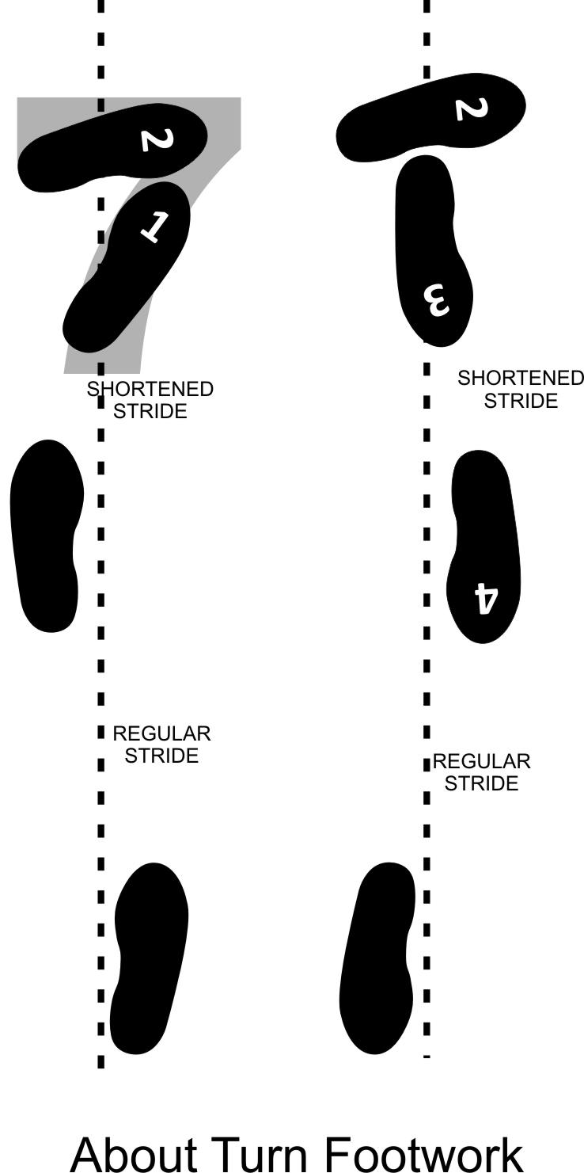
About Turns
First, we’ll review the “half about turn.” Step forward with your right foot, and bring your left foot around in front of the right, creating the No. 7. Rotate your shoulders to the right and bring the food tightly around you and reward next to your right leg.
Now you will repeat the above and add steps 3 and 4. You will complete the turn by turning your right foot towards your new direction, then following it with your left foot. You will now reward the dog just in front of your left leg. Always keep feet close together and under your shoulders.
Make the About Turn FUN and EXCITING for your dog. You will be luring quickly around the turn and rewarding as soon as the turn is completed for quite a number of repetitions. (Around 100+ times) Later you must drop the lure and just reward when the turn is completed.
Figure 8’s
INSIDE HALF—The object for the inside half is to teach your dog to move slightly slower than you and heel without forging. In practice this half needs to be done VERY SLOWLY for a VERY LONG time. You should reward at least 2-3 times per circle for weeks and weeks! Step, step, reward, step, step, step, reward. Don’t be stingy!
Food should be in your LEFT hand. Leash, for most dogs should probably be behind you. Remember doing ¼ turns left around the box? Pretend the post/person/cone is that box. Remember to walk slowly and reward every few steps and/or every time your dog moves his butt in.
OUTSIDE HALF—Remember the Driving Right? We want the dog to power into this outside circle because now the dog must move faster than the handler. You just won’t be doing a tight drive right, rather a circle right.

Homework
- Practice Doggie Zen with hands at your side and rewarding for looking at your face. Practice moving back a step and encourage your dog to move with you, while still maintaining focus on your face.

EXTRAS
ADVANCED
Transitions from Normal to slow to Normal. Etc.

Focus On Heeling Syllabus Week 4
The Perfect Figure 8
The perfect figure 8 requires a bit of practice without the dog before you bring the dog into the picture. Think of it as two half circles (one around the back of each post) joined by an ‘X’. Making straight lines across the center enables the dog to heel more accurately. Practice at home using two garbage cans, cones or stools 8’ apart. Make “airplane arms”.
Hand outs of the Figure 8

Celeste Meade – Pick ups. Getting into Place from any location.

Leave dog, call to heel and reward when they catch up. Add turns and circles.
